Hands-On Lab
Lab Manual
Build a simple MVC Portlet App using CoreWa

Contents
Lab: Building a simple MVC Portlet App using CoreWa 3
Lab Objectives 3
Exercise 1 – Create a simple portlet application to add and list students. 4
1. Create a new Dynamic Web Project. 4
2. Create new portlet object: StudentPortlet 5
3. Create utility class(s). 7
3. Using sample_layout in corewa 8
4. About the MVC using CoreWa 8
5. Modify the JSPs. 11
6. Refresh and then, run the project. 11
7. Righ-click on the project, select Run As > Run on Server. 11
8. Open the portlet in the browser. 12
Exercise 2 – Implement coding for StudentDemoUsingCoreWa project. 14
1. Create database query. 14
2. Import the necessary libraries into StudentDemoUsingCoreWa project. 14
3. Create DTO class(s). 14
4. Create DAO class(s). 18
5. Create BLO class(s). 25
6. Create StudentPortlet class 26
7. Create control class(s): 28
8. Modify the JSP and XML files: 30
9. Refresh and then, run the project. 33
10. Righ-click on the project, select Run As > Run on Server. 33

Lab: Building a simple MVC Portlet App using CoreWa
Estimated time to complete this lab: 50 minutes.

Lab Objectives
This lab will guide you to building a simple MVC Porlet application using CoreWa:
Fisrt of all, take a view at resource of CoreWa in http://open-ones.googlecode.com/svn/trunk/CoreWa/SourceCode/CoreWa/.
- Portlet.
- Log4j library to tracking your project’s flow.
- MySQL DBMS.
- Using *.properties file in Java with Properties object and ResourceBundle object.

References:
- Log4j: http://www.vipan.com/htdocs/log4jhelp.html

Exercise 1 – Create a simple portlet application to add and list students.
  - Create a new Dynamic Web Project.
- Goining to menu File > New > Dynamic Web Project. Input the values as following figure.

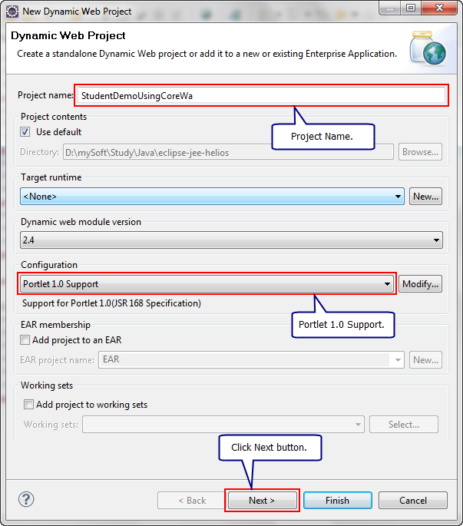

- In the next dialog, click Next button.

- In this dialog, let modify the value of Context root: change from StudentDemoUsingCoreWa to portletdriver/dt.
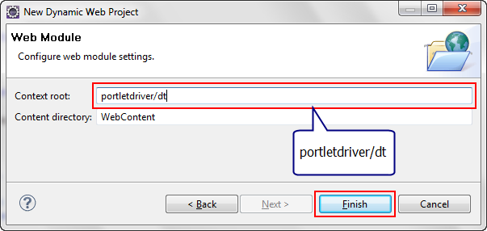
- Click on Finish button. The structure of the project is:
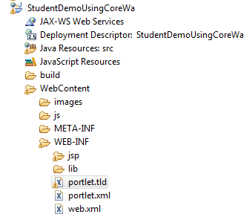
  - Create new portlet object: StudentPortlet
- Going menu New > Other…, select node Porlet\Java Porlet.

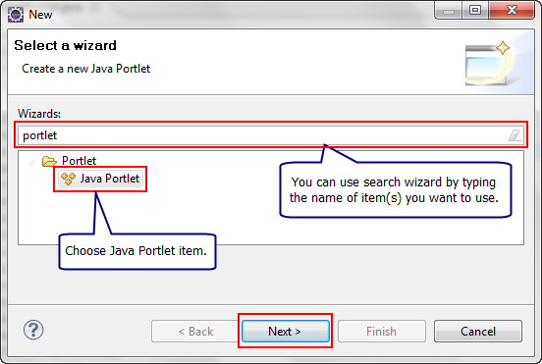

- Click on Next button.

- Input information for StudentPortlet portlet as following:
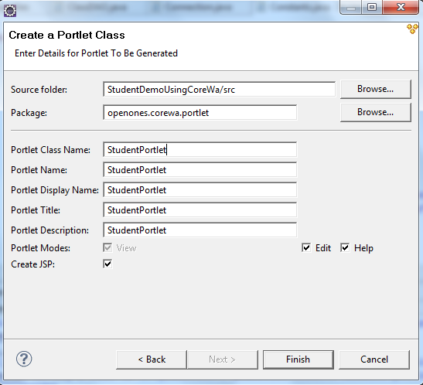
- Click on Finish button. The structure of the project is:
  - Create utility class(s).
In package openones.corewa.util:

- Create Constants.java class :

package openones.corewa.util;

/**
* Constants of project.
* @author HaLT
*
*/
public class Constants {
public static String JDBD_DRIVER = "jdbcDriver";
public static String JDBD_URL = "jdbcUrl";
public static String JDBD_USER = "jdbcUser";
public static String JDBD_PASS = "jdbcPassword";

public static String BLANK_VALUE = "";

public static String ADD_ACTION = "add";
public static String LIST_ACTION = "list";
public static String BACK_ACTION = "back";

public static String ADD_VIEW_PATH = "/WEB-INF/jsp/AddStudentPortlet_view.jsp";
public static String LIST_VIEW_PATH = "/WEB-INF/jsp/ListStudent.jsp";

public static String ERR_MESS_PORT_SESS_ATT = "errorMess";
}

- Create Connection.java class :

package openones.corewa.util;

import java.io.InputStream;
import java.sql.DriverManager;
import java.util.Properties;
import java.util.ResourceBundle;
import org.apache.log4j.Logger;

/**
* This class uses to get database connection.
*
* @author HaLT
*
*/
public class Connection {
/**
* props property. Contain the content of db.properties file.
*/
private static Properties props = new Properties();

/**
* log property.
*/
private static Logger log = Logger.getLogger("Connection");

// load the content of db.properties file.
static {
try {
InputStream is = Connection.class
.getResourceAsStream("/db.properties");
props.load(is);
} catch (Exception ex) {
// in case occur exception, log it.
log.error("Load db.properties", ex);
}
}

private static ResourceBundle dbResource = ResourceBundle.getBundle("db");

public static java.sql.Connection getConnection() {
// load the driver and establish a connection.
try {
// using resource bundle to get jdbcDriver
String jdbcDriver = dbResource.getString(Constants.JDBD_DRIVER);
String jdbcUrl = dbResource.getString(Constants.JDBD_URL);

// using properties object.
String jdbcUser = props.getProperty(Constants.JDBD_USER);
String jdbcPassword = props.getProperty(Constants.JDBD_PASS);

Class.forName(jdbcDriver);
return (java.sql.Connection) DriverManager.getConnection(jdbcUrl,
jdbcUser, jdbcPassword);
} catch (Exception ex) {
log.error("getConnection", ex);
}
return null;
}
}

- Using sample_layout in corewa
- In your src folder:
Using some packages: openones.corewa ,openones.corewa.control, openones.corewa.form that you have had on resource of CoreWa
- In your src_sample_layout folder:
Using some packages: openonse.corewalayoutdemo
- Using sample_layout_pages of CoreWa, it contains some sample pages that using CoreWa
- About the MVC using CoreWa
- CoreWa using XML to define the main flow of application and handle the events
- Here is the first XML file, it defines the layouts of application
<?xml version="1.0" encoding="UTF-8"?>
<corewa>
<layout id="Layout">
<part id="layout.do" screen="Layout"/>
<part id="header.do" screen="Header"/>
<part id="left.do" screen="Left"/>
<part id="main.do" screen="Main"/>
<part id="right.do" screen="Right"/>
<part id="footer.do" screen="Footer"/>
</layout>
<home-screen>Layout</home-screen>

<screen id="Layout" control="openones.corewa.control.LayoutControl" input="/WEB-INF/sample_layout_pages/layout.jsp">
</screen>
<corewa>

Every main screen will have an ID, its Controller and the location of jps page
- Others screen can be defined in separate XML files:

<?xml version="1.0" encoding="UTF-8"?>
<corewa>
<home-screen>Header</home-screen>

<screen id="Header" control="openones.corewa.control.MenuControl" input="/WEB-INF/sample_layout_pages/header.jsp">
</screen>
</corewa>

<?xml version="1.0" encoding="UTF-8"?>
<corewa>
<home-screen>Main</home-screen>

<screen id="Main" input="/WEB-INF/sample_layout_pages/add.jsp">
<event id="Menu" redirect="yes" nextScreen="/WEB-INF/sample_layout_pages/menu.jsp" />
<event id="List" redirect="yes" nextScreen="/WEB-INF/sample_layout_pages/list.jsp" />
</screen>

<screen id="Menu" input="/WEB-INF/sample_layout_pages/menu.jsp">
<event id="List" redirect="yes" nextScreen="/WEB-INF/sample_layout_pages/list.jsp" />
<event id="Add" redirect="yes" nextScreen="/WEB-INF/sample_layout_pages/add.jsp" />
</screen>

<screen id="List" input="/WEB-INF/sample_layout_pages/list.jsp">
<event id="goMenu" redirect="yes" nextScreen="/WEB-INF/sample_layout_pages/menu.jsp" />
</screen>
</corewa>

- Some screen will need an Controller to handle events, here is the Layout screen’s Controller:
public class LayoutControl extends BaseControl {

@Override
public BaseOutForm procInit(HttpServletRequest req, HttpServletResponse resp) throws ServletException, IOException {
BaseOutForm outForm = new BaseOutForm();
outForm.putSession("user", "Guest");

return outForm;
}

}

- Here is the main layout of application:

<%@ page language="java" contentType="text/html; charset=UTF-8"
pageEncoding="UTF-8"%>
<!DOCTYPE html PUBLIC "-//W3C//DTD HTML 4.01 Transitional//EN" "http://www.w3.org/TR/html4/loose.dtd">
<html>
<head>
<meta http-equiv="Content-Type" content="text/html; charset=UTF-8">
<title>CoreWa demo - Add</title>
<script type="text/javascript" src='pages/scripts/common.js'></script>
</head>
<body>
Tôi yêu tiếng nước tôi!
Index layout. Welcome <%= session.getAttribute("user") %>
<table border="1" width="100%" cellspacing="0" cellpadding="0">
<tr>
<td colspan="3">
<jsp:include page="/header.part"/>
</td>
</tr>
<tr>
<td width="13%">
Left
</td>
<td width="68%" height="200"><jsp:include page="/main.part"/>
</td>
<td width="18%">Right
</td>
</tr>
<tr>
<td colspan="3">Footer
</td>
</tr>
</table>
</body>
</html>

It contain the Header, Left, Main, Right and Footer part, the page *.part in the <jsp:include> tag is the screen that have defined above, for example, when we include header.part, it will include the Header screen that defined in the sample_layout.xml:

<part id="header.do" screen="Header"/>

In Header screen, it will include the header.jsp page:

<screen id="Header" control="openones.corewa.control.MenuControl" input="/WEB-INF/sample_layout_pages/header.jsp">
</screen>

- Modify the JSPs.
- Open the StudentDemoUsingCoreWa\WebContent\WEB-INF\sample_layout_pages\add.jsp file. You can use the hot key Ctrl + Shift + R to open one file/resource quickly. This file is the main page of application.
- Modify the content of this file as following:

<%@ page language="java" contentType="text/html; charset=UTF-8" pageEncoding="UTF-8"%>
<form name="MainForm" action="main.do">
Main page
<input type="hidden" name="screenId" value="Main">
<input type="hidden" name="eventId" value="Menu">
<input type="submit" value="Manage Students">
</form>

- Open the StudentDemoUsingCoreWa\WebContent\WEB-INF\jsp\StudentPortlet_view.jsp file.
- Modify the content of this file as following:
<%@page contentType="text/html"%>
<%@page pageEncoding="UTF-8"%>

<%@ page import="javax.portlet.*"%>
<%@ taglib uri="http://java.sun.com/portlet" prefix="portlet"%>

<portlet:defineObjects />

<jsp:include page="../sample_layout_pages/layout.jsp"/>

- Refresh and then, run the project.
- Righ-click on the project, select Run As > Run on Server.
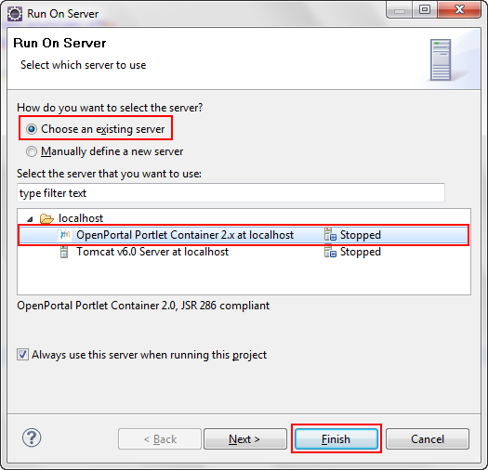
- If no available server exists, you have to add a new server to run project.

- Open the portlet in the browser.

- Open the browser with the url: http://localhost:9090/portletdriver/dt
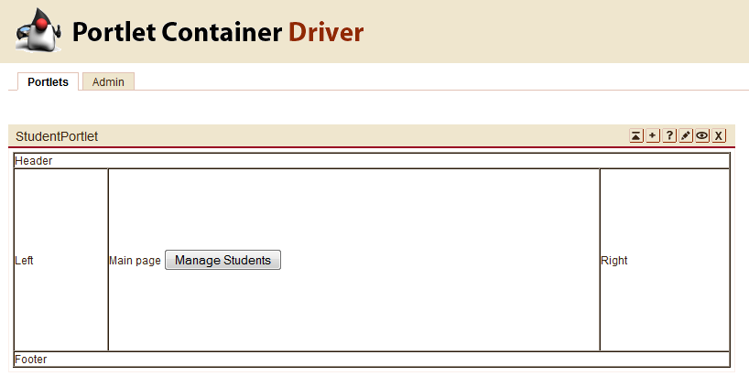
- Then, deploy into uPortal, after you deploy it successfully in uPortal.

Exercise 2 – Implement coding for StudentDemoUsingCoreWa project.
  - Create database query.
- In MySQL, create new database with name is portal and run the script as following:

-- ----------------------------
-- Table structure for `class`
-- ----------------------------
DROP TABLE IF EXISTS `class`;
CREATE TABLE `class` (
`classId` char(255) NOT NULL,
`className` char(255) DEFAULT NULL,
PRIMARY KEY (`classId`)
) ENGINE=InnoDB DEFAULT CHARSET=utf8;

-- ----------------------------
-- Records of class
-- ----------------------------
INSERT INTO `class` VALUES ('DH07DTH', 'DH07DTH');
INSERT INTO `class` VALUES ('DH07DTM', 'DH07DTM');
INSERT INTO `class` VALUES ('DH08DT', 'DH08DT');
INSERT INTO `class` VALUES ('DH09DT', 'DH09DT');

-- ----------------------------
-- Table structure for `student`
-- ----------------------------
DROP TABLE IF EXISTS `student`;
CREATE TABLE `student` (
`studentId` varchar(255) NOT NULL,
`studentName` varchar(255) DEFAULT NULL,
`birthday` date DEFAULT NULL,
`classId` varchar(255) DEFAULT NULL,
`mark` float DEFAULT NULL,
`email` varchar(255) DEFAULT NULL,
`avatar` varchar(255) DEFAULT NULL,
PRIMARY KEY (`studentId`)
) ENGINE=InnoDB DEFAULT CHARSET=utf8;

-- ----------------------------
-- Records of student
-- ----------------------------
INSERT INTO `student` VALUES ('07130028', 'Lưu Thúy Hà', '1989-09-08', 'DH07DTH', '9', 'luuhait@gmail.com', null);
INSERT INTO `student` VALUES ('07130112', 'Nhjm', '1989-09-08', 'DH07DTM', '8.9', 'lthsunflower@yahoo.com', 'Avatar5.jpg');

  - Import the necessary libraries into StudentDemoUsingCoreWa project.
- log4j-1.2.15.jar: this is used for log4j.
- mysql-connector-java-5.1.6-bin.jar: this is MySQL driver.
- standard.jar: this is used for JSTL.
- jstl.jar: this is used for JSTL.

Download these *.jar file and copy them to \WEB-INF\lib folder of StudentDemoUsingCoreWa project, then refresh project again.
  - Create DTO class(s).
In package openones.corewa.dto

- Create SimpleClassDTO.java class as following:
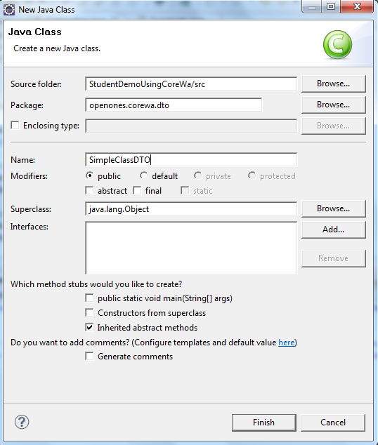

  - This class use to :
Represent the Class Object, it store the Class’s data

  - Content of this class:
package openones.corewa.dto;

/**
*
* @author HaLT
*
*/
public class SimpleClassDTO {
private String id;
private String name;

public String getId() {
return id;
}

public void setId(String id) {
this.id = id;
}

public String getName() {
return name;
}

public void setName(String name) {
this.name = name;
}

}
/**
* Set the value for id.
* @param id the id to set
*/
public void setId(int id) {
this.id = id;
}

/**
* Get value of name.
* @return the name
*/
public String getName() {
return name;
}

/**
* Set the value for name.
* @param name the name to set
*/
public void setName(String name) {
this.name = name;
}

public GroupDTO(){
this.id = -1;
this.name = "";
}

public GroupDTO(int id, String name)
{
this.id = id;
this.name = name;
}
}

- Create SimpleStudentDTO class as following:
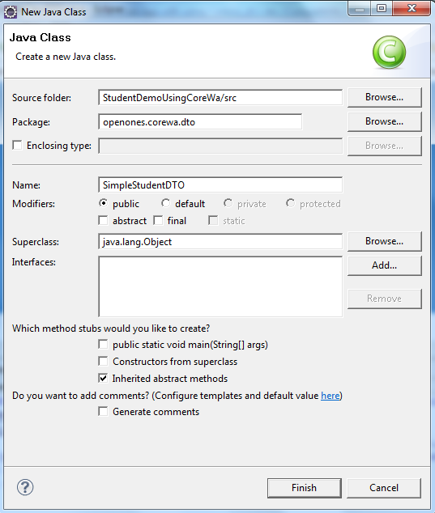

  - This class use to:
Represent the Student Object, it store the Student’s data

  - Content of this class:
package openones.corewa.dto;

import java.util.Date;
/**
*
* @author HaLT
*
*/
public class SimpleStudentDTO {
private String id;
private String name;
private Date birthday;
private String avatar;
private SimpleClassDTO sClass;
private float mark;
private String email;

public String getId() {
return id;
}
public void setId(String id) {
this.id = id;
}
public String getName() {
return name;
}
public void setName(String name) {
this.name = name;
}
public Date getBirthday() {
return birthday;
}
public void setBirthday(Date birthday) {
this.birthday = birthday;
}
public String getAvatar() {
return avatar;
}
public void setAvatar(String avatar) {
this.avatar = avatar;
}
public SimpleClassDTO getsClass() {
return sClass;
}
public void setsClass(SimpleClassDTO sClass) {
this.sClass = sClass;
}
public float getMark() {
return mark;
}
public void setMark(float mark) {
this.mark = mark;
}
public String getEmail() {
return email;
}
public void setEmail(String email) {
this.email = email;
}

}

  - Create DAO class(s).
In package openones.corewa.dao

- Create ClassDAO.java as following:
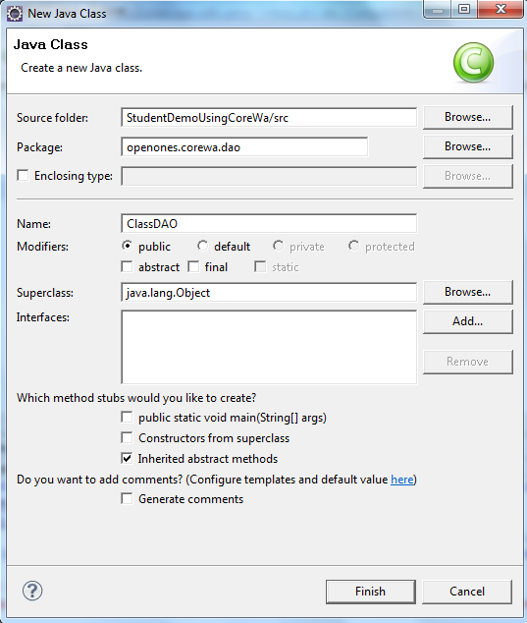
  - This class use to:
Object that access to the database and provides some methods for Class class

  - Content of this class:

package openones.corewa.dao;

import java.sql.Connection;
import java.sql.PreparedStatement;
import java.sql.ResultSet;
import java.sql.SQLException;
import java.sql.Statement;
import java.util.ArrayList;
import java.util.List;

import openones.corewa.dto.SimpleClassDTO;
import openones.corewa.util.Constants;

import org.apache.log4j.Logger;

/**
*
* @author HaLT
*
*/
public class ClassDAO {
private static Logger log = Logger.getLogger("ClassDAO");

public SimpleClassDTO getClass(String id) {
SimpleClassDTO dto = null;
Connection conn = null;
String query = Constants.BLANK_VALUE;
ResultSet rs = null;
PreparedStatement pStat = null;

try {
// query command
query = "select * from class where classId=?";
// get connection
conn = openones.corewa.util.Connection.getConnection();
// prepare statement
pStat = conn.prepareStatement(query);
pStat.setString(1, id);
// execute query
rs = pStat.executeQuery();
// get result
while (rs.next()) {
dto = new SimpleClassDTO();
dto.setId(rs.getString("classId"));
dto.setName(rs.getString("className"));
}
} catch (Exception sqlEx) {
log.error("ClassDAO.getClass " + sqlEx);
} finally {
try {
rs.close();
pStat.close();
conn.close();
} catch (SQLException sqlEx) {
log.error("ClassDAO.getClass " + sqlEx);
}
}
return dto;
}
public List<SimpleClassDTO> getAllClass() {
List<SimpleClassDTO> list = new ArrayList<SimpleClassDTO>();
SimpleClassDTO dto = null;
Connection conn = null;
String query = Constants.BLANK_VALUE;
ResultSet rs = null;
Statement stat = null;

try {
// query command
query = "select * from class";
// get connection
conn = openones.corewa.util.Connection.getConnection();
stat = conn.createStatement();
// execute query
rs = stat.executeQuery(query);
// get result
while (rs.next()) {
dto = new SimpleClassDTO();
dto.setId(rs.getString("classId"));
dto.setName(rs.getString("className"));
list.add(dto);
}
} catch (Exception sqlEx) {
log.error("ClassDAO.getAllClass " + sqlEx);
} finally {
try {
rs.close();
stat.close();
conn.close();
} catch (SQLException sqlEx) {
log.error("ClassDAO.getAllClass " + sqlEx);
}
}
return list;
}
}

- Create StudentDAO.java as following
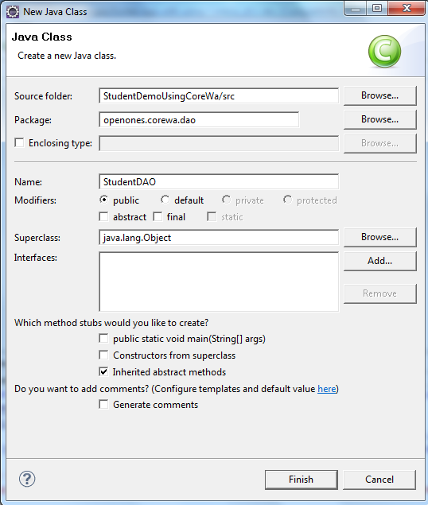
  - This class use to:
Object that access to the database and provides some methods for Student class

  - Content of this class:

package openones.corewa.dao;

import java.sql.Connection;
import java.sql.PreparedStatement;
import java.sql.ResultSet;
import java.sql.SQLException;
import java.sql.Statement;
import java.util.ArrayList;
import java.util.List;

import openones.corewa.dto.SimpleClassDTO;
import openones.corewa.dto.SimpleStudentDTO;
import openones.corewa.util.Constants;

import org.apache.log4j.Logger;

/**
*
* @author HaLT
*
*/
public class StudentDAO {
private static Logger log = Logger.getLogger("StudentDAO");

public SimpleStudentDTO getStudent(String id) {
SimpleStudentDTO dto = null;
Connection conn = null;
String query = Constants.BLANK_VALUE;
ResultSet rs = null;
PreparedStatement pStat = null;

try {
// query command
query = "select * from student where studentId=?";
// get connection
conn = openones.corewa.util.Connection.getConnection();
// prepare statement
pStat = conn.prepareStatement(query);
pStat.setString(1, id);
// execute query
rs = pStat.executeQuery();
// get result
while (rs.next()) {
dto = new SimpleStudentDTO();
dto.setId(rs.getString("studentId"));
dto.setName(rs.getString("studentName"));
dto.setBirthday(rs.getDate("birthday"));
dto.setAvatar(rs.getString("avatar"));
String classId = rs.getString("classId");
ClassDAO classDAO = new ClassDAO();
SimpleClassDTO simpleClassDTO = classDAO.getClass(classId);
dto.setsClass(simpleClassDTO);
dto.setMark(rs.getFloat("mark"));
dto.setEmail(rs.getString("email"));
}
} catch (Exception sqlEx) {
log.error("SimpleLoginDAO.getUser " + sqlEx);
} finally {
try {
rs.close();
pStat.close();
conn.close();
} catch (SQLException sqlEx) {
log.error("SimpleLoginDAO.getUser " + sqlEx);
}
}

return dto;
}
public List<SimpleStudentDTO> getAllStudent() {
List<SimpleStudentDTO> list = new ArrayList<SimpleStudentDTO>();
SimpleStudentDTO dto = null;
Connection conn = null;
String query = Constants.BLANK_VALUE;
ResultSet rs = null;
Statement stat = null;

try {
// query command
query = "select * from student";

// get connection
conn = openones.corewa.util.Connection.getConnection();
stat = conn.createStatement();

// execute query
rs = stat.executeQuery(query);

// get result
while (rs.next()) {
dto = new SimpleStudentDTO();
dto.setId(rs.getString("studentId"));
dto.setName(rs.getString("studentName"));
dto.setBirthday(rs.getDate("birthday"));
dto.setAvatar(rs.getString("avatar"));
String classId = rs.getString("classId");
ClassDAO classDAO = new ClassDAO();
SimpleClassDTO simpleClassDTO = classDAO.getClass(classId);
dto.setsClass(simpleClassDTO);
dto.setMark(rs.getFloat("mark"));
dto.setEmail(rs.getString("email"));
list.add(dto);
}
} catch (Exception sqlEx) {
log.error("ClassDAO.getAllClass " + sqlEx);
} finally {
try {
rs.close();
stat.close();
conn.close();
} catch (SQLException sqlEx) {
log.error("ClassDAO.getAllClass " + sqlEx);
}
}
return list;
}

public boolean insertStudent(String id, String name, String birthday,
String classId, float mark, String email, String avatar) {
boolean result = false;
Connection conn = null;
String query = Constants.BLANK_VALUE;
PreparedStatement pStat = null;

try {

// query command
query = "insert into student (studentId, studentName, birthday, classId, mark, email, avatar) values (?, ?, ?, ?, ?, ?, ?)";

// get connection
conn = openones.corewa.util.Connection.getConnection();

// prepare statement
pStat = conn.prepareStatement(query);
pStat.setString(1, id);
pStat.setString(2, name);
pStat.setString(3, birthday);

pStat.setString(4, classId);
pStat.setFloat(5, mark);
pStat.setString(6, email);
pStat.setString(7, avatar);
// execute query
int i = pStat.executeUpdate();
if (i > 0)
result = true;
;
} catch (Exception sqlEx) {
log.error("SimpleLoginDAO.insert " + sqlEx);
} finally {
try {
pStat.close();
conn.close();
} catch (SQLException sqlEx) {
log.error("SimpleLoginDAO.insert " + sqlEx);
}
}

return result;
}

}

  - Create BLO class(s).
In package openones.corewa.blo
- Create StudentBLO.java as following:
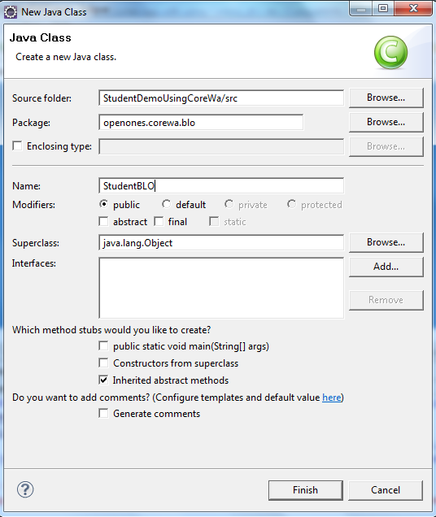
  - This class use to:
Process business logic for the application

  - Content of this class:

package openones.corewa.blo;

import java.util.List;

import openones.corewa.dao.ClassDAO;
import openones.corewa.dao.StudentDAO;
import openones.corewa.dto.SimpleClassDTO;
import openones.corewa.dto.SimpleStudentDTO;

import org.apache.log4j.Logger;

/**
* Process business logic for SimpleLoginPortlet.
* @author HaLT
*
*/
public class StudentBLO {
/**
* log property.
*/
private static Logger log = Logger.getLogger("AddStudentBLO");

/**
* DAO property.
*/
private StudentDAO studentDAO = new StudentDAO();
private ClassDAO classDAO = new ClassDAO();

public boolean checkExistStudent(String id) {
log.debug("checkExistStudent.start");

boolean res = false;
SimpleStudentDTO dto = (SimpleStudentDTO) studentDAO.getStudent(id);
if (dto == null) {
res = true;
}

log.debug("checkExistStudent.end");
return res;
}

public boolean insertStudent (String id, String name, String birthday, String classId, float mark, String email, String avatar){
return studentDAO.insertStudent(id, name, birthday, classId, mark, email, avatar);
}

public List<SimpleStudentDTO> getAllStudent(){
return studentDAO.getAllStudent();
}

public List<SimpleClassDTO> getAllClass(){
return classDAO.getAllClass();
}
}

  - Create StudentPortlet class
In package openones.corewa.portlet:
- Add content to StudentPortlet.java
package openones.corewa.portlet;

import javax.portlet.GenericPortlet;
import javax.portlet.ActionRequest;
import javax.portlet.RenderRequest;
import javax.portlet.ActionResponse;
import javax.portlet.RenderResponse;
import javax.portlet.PortletException;
import java.io.IOException;

import javax.portlet.PortletRequestDispatcher;

import openones.corewa.blo.StudentBLO;
import openones.corewa.util.Constants;

import org.apache.log4j.Logger;

/**
* StudentPortlet Portlet Class
*
* @author HaLT
*/
public class StudentPortlet extends GenericPortlet {
private StudentBLO blo;
private String action = Constants.BLANK_VALUE;
private static Logger log = Logger.getLogger("AddStudentPortlet");

public void doView(RenderRequest request, RenderResponse response)
throws PortletException, IOException {

response.setContentType("text/html");

// blo = new StudentBLO();
// List<SimpleClassDTO> classes = blo.getAllClass();
// request.setAttribute("classes", classes);
PortletRequestDispatcher dispatcher = getPortletContext()
.getRequestDispatcher("/WEB-INF/jsp/StudentPortlet_view.jsp");
dispatcher.include(request, response);

}

public void doEdit(RenderRequest request, RenderResponse response)
throws PortletException, IOException {

response.setContentType("text/html");

PortletRequestDispatcher dispatcher = getPortletContext()
.getRequestDispatcher("/WEB-INF/jsp/StudentPortlet_edit.jsp");
dispatcher.include(request, response);

}

public void doHelp(RenderRequest request, RenderResponse response)
throws PortletException, IOException {

response.setContentType("text/html");

PortletRequestDispatcher dispatcher = getPortletContext()
.getRequestDispatcher("/WEB-INF/jsp/StudentPortlet_help.jsp");
dispatcher.include(request, response);

}

public void processAction(ActionRequest request, ActionResponse response)
throws PortletException, IOException {
}
}
  - Create control class(s):
In package openones.corewa.control:
- Create LayoutControl.java
  - This class is the controller for the main layout of the application (layout.jsp)
- Create MenuControl.java
  - This class is the controller for the main menu (Add student and List students) of the application
  - Content of this class:

public class MenuControl extends BaseControl {

@Override
public BaseOutForm procInit(HttpServletRequest req, HttpServletResponse resp)
throws ServletException, IOException {
StudentBLO blo = new StudentBLO();
BaseOutForm outForm = new BaseOutForm();
if (req.getParameter("eventId").equals("Add")) {
List<SimpleClassDTO> classes = blo.getAllClass();
outForm = new BaseOutForm();
outForm.putRequest("classes", classes);
} else if (req.getParameter("eventId").equals("List")) {
List<SimpleStudentDTO> listStudents = blo.getAllStudent();
outForm = new BaseOutForm();
outForm.putRequest("students", listStudents);
} else {
return super.procInit(req, resp);
}
return outForm;
}
- AddStudentControl.java
  - This class is use to handle inserting new student to the database
  - Content of this class:
public class AddStudentControl extends BaseControl {

@Override
public BaseOutForm procInit(HttpServletRequest req, HttpServletResponse resp)
throws ServletException, IOException {
if (req.getParameter("eventId") != null && req.getParameter("eventId").equals("Submit")) {
StudentBLO blo = new StudentBLO();
BaseOutForm outForm = new BaseOutForm();
List<SimpleClassDTO> classes = blo.getAllClass();
outForm = new BaseOutForm();
outForm.putRequest("classes", classes);

String studentId = req.getParameter("studentId");
String studentName = req.getParameter("studentName");
int day = Integer.parseInt(req.getParameter("day"));
int month = Integer.parseInt(req.getParameter("month"));
int year = Integer.parseInt(req.getParameter("year"));
String dayStr = day < 10 ? "0" + day : day + "";
String monthStr = month < 10 ? "0" + month : month + "";
String birthday = year + "-" + monthStr + "-" + dayStr;
String classId = req.getParameter("classId");
String markStr = req.getParameter("mark");
float mark = 0;
String email = req.getParameter("email");
String avatar = req.getParameter("avatar");
if (avatar == null)
avatar = "";

String error = "";
if (studentId == null || studentId.equals(""))
error = "Please input Student Id";
else {
try {
mark = Float.parseFloat(markStr);
} catch (NumberFormatException e) {
error = "Mark must be a positive number";
}
}

if (! error.equals("")){
outForm.putRequest("error", error);
return outForm;
} else {
if (blo.insertStudent(studentId, studentName, birthday, classId, mark, email, avatar))
outForm.putRequest("addResult", "Student has been added successfully !");
else
outForm.putRequest("error", "Student ID is already exist");
return outForm;
}
} else
return super.procInit(req, resp);

}

}

  - Modify the JSP and XML files:
- Modify the content of StudentDemoUsingCoreWa\WebContent\WEB-INF\sample_layout_pages\menu.jsp as following:
<%@ page language="java" contentType="text/html; charset=UTF-8"
pageEncoding="UTF-8"%>
<!DOCTYPE html PUBLIC "-//W3C//DTD HTML 4.01 Transitional//EN" "http://www.w3.org/TR/html4/loose.dtd">
<html>
<head>
<meta http-equiv="Content-Type" content="text/html; charset=UTF-8">
<title>CoreWa demo</title>
</head>

<body>
<form action="main.do">
<input type="hidden" name="screenId" value="Menu">
<input type="hidden" name="eventId" value="Add">
<input type="submit" value="Add Student">
</form>
<form action="main.do">
<input type="hidden" name="screenId" value="Menu">
<input type="hidden" name="eventId" value="List">
<input type="submit" value="View Students">
</form>
</body>
</html>

This is the main menu of application, it have two main functions are Add Stuedent and View Students.
- Modiy the main.xml as following:

<?xml version="1.0" encoding="UTF-8"?>
<corewa>
<home-screen>Main</home-screen>

<screen id="Main" input="/WEB-INF/sample_layout_pages/main.jsp">
<event id="Menu" redirect="yes" nextScreen="/WEB-INF/sample_layout_pages/menu.jsp" />
</screen>

<screen id="Menu" control="openones.corewa.control.MenuControl" input="/WEB-INF/sample_layout_pages/menu.jsp">
<event id="Add" redirect="yes" nextScreen="/WEB-INF/sample_layout_pages/AddStudent.jsp" />
<event id="List" redirect="yes" nextScreen="/WEB-INF/sample_layout_pages/ViewStudents.jsp" />
</screen>

<screen id="Add" control="openones.corewa.control.AddStudentControl" input="/WEB-INF/sample_layout_pages/AddStudent.jsp">
<event id="Submit" redirect="yes" nextScreen="/WEB-INF/sample_layout_pages/AddStudent.jsp" />
<event id="Back" redirect="yes" nextScreen="/WEB-INF/sample_layout_pages/menu.jsp" />
</screen>

<screen id="List" input="/WEB-INF/sample_layout_pages/ViewStudents.jsp">
<event id="Back" redirect="yes" nextScreen="/WEB-INF/sample_layout_pages/menu.jsp" />
</screen>
</corewa>

<screen id="List" input="/WEB-INF/sample_layout_pages/ViewStudents.jsp">
<event id="Back" redirect="yes" nextScreen="/WEB-INF/sample_layout_pages/menu.jsp" />
</screen>
</corewa>

- Modify the /WEB-INF/sample_layout_pages/AddStudent.jsp:

<!DOCTYPE html PUBLIC "-//W3C//DTD HTML 4.01 Transitional//EN" "http://www.w3.org/TR/html4/loose.dtd">
<%@page contentType="text/html"%>
<%@page pageEncoding="UTF-8"%>

<%@ page import="javax.portlet.*"%>
<%@page import="openones.corewa.blo.StudentBLO"%>
<%@page import="java.util.List"%>
<%@page import="openones.corewa.dto.SimpleClassDTO"%>
<%@page import="java.util.ArrayList"%>
<%@ taglib uri="http://java.sun.com/portlet" prefix="portlet"%>
<html>
<head>
<meta http-equiv="Content-Type" content="text/html; charset=UTF-8">
<title>Add Student</title>
</head>

<body>
<%
String error = (String)request.getAttribute("error");
if (error == null)
error = "";
String addResult = (String)request.getAttribute("addResult");
if (addResult == null)
addResult = "";
List<SimpleClassDTO> classes = (List<SimpleClassDTO>)request.getAttribute("classes");
if (classes == null)
classes = new ArrayList<SimpleClassDTO>();
%>

<script type="text/javascript">
function submitForm(frm, eventId) {
frm.eventId.value = eventId;
frm.submit();
}
</script>

<portlet:defineObjects />

<font color="red"><%= error %></font>
<%= addResult %>
<form id="addForm" action="main.do">
<table>
<tr>
<td>Student code:</td>
<td><input type="text" name="studentId"></td>
</tr>
<tr>
<td>Full name:</td>
<td><input type="text" name="studentName"></td>
</tr>
<tr>
<td>Birthday:</td>
<td>
<select name="day">
<% for (int i = 1; i <= 31; i ++) { %>
<option value=<%= i %>><%= i %></option>
<% } %>
</select>
<select name="month">
<% for (int i = 1; i <= 12; i ++) { %>
<option value=<%= i %>><%= i %></option>
<% } %>
</select>
<select name="year">
<% for (int i = 1945; i <= 2011; i ++) { %>
<option value=<%= i %>><%= i %></option>
<% } %>
</select>
<!--
<input class="datepicker" type="text" name="birthday"/>
<script type="text/javascript">
new Control.DatePicker('birthday', { icon: '../css/calendar.png', dateFormat: 'dd/MM/yyyy'});
</script>
-->
</td>
</tr>
<tr>
<td>Class:</td>
<td>
<select name="classId">
<% for (int i = 0; i < classes.size(); i ++) { %>
<option value="<%= classes.get(i).getId() %>"><%= classes.get(i).getName() %></option>
<% } %>
</select>
</td>
</tr>
<tr>
<td>Mark:</td>
<td><input type="text" name="mark"></td>
</tr>
<tr>
<td>Email:</td>
<td><input type="text" name="email"></td>
</tr>
<tr>
<td>Avatar:</td>
<td><input type="file" name="avatar"></td>
</tr>
<tr>
<td></td>
<td>
<input type="hidden" name="screenId" value="Add" />
<input type="hidden" name="eventId" value="">
<input type="button" name="Submit" value="Submit" onclick="submitForm(document.getElementById('addForm'), 'Submit');">
<input type="button" name="Back" value="Back" onclick="submitForm(document.getElementById('addForm'), 'Back');">
</td>
</tr>
</table>
</form>
</body>
</html>

<td>Birthday:</td>
<td>
<select name="day">
<% for (int i = 1; i <= 31; i ++) { %>
<option value=<%= i %>><%= i %></option>
<% } %>
</select>
<select name="month">
<% for (int i = 1; i <= 12; i ++) { %>
<option value=<%= i %>><%= i %></option>
<% } %>
</select>
<select name="year">
<% for (int i = 1945; i <= 2011; i ++) { %>
<option value=<%= i %>><%= i %></option>
<% } %>
</select>
</td>
</tr>
<tr>
<td>Class:</td>
<td>
<select name="classId">
<% for (int i = 0; i < classes.size(); i ++) { %>
<option value="<%= classes.get(i).getId() %>"><%= classes.get(i).getName() %></option>
<% } %>
</select>
</td>
</tr>
<tr>
<td>Mark:</td>
<td><input type="text" name="mark"></td>
</tr>
<tr>
<td>Email:</td>
<td><input type="text" name="email"></td>
</tr>
<tr>
<td>Avatar:</td>
<td><input type="file" name="avatar"></td>
</tr>
<tr>
<td></td>
<td>
<input type="hidden" name="screenId" value="Add" />
<input type="hidden" name="eventId" value="">
<input type="button" name="Submit" value="Submit" onclick="submitForm(document.getElementById('addForm'), 'Submit');">
<input type="button" name="Back" value="Back" onclick="submitForm(document.getElementById('addForm'), 'Back');">
</td>
</tr>
</table>
</form>
</body>
</html>

- Modify the /WEB-INF/sample_layout_pages/ViewStudents.jsp:

<%@page import="openones.corewa.dto.SimpleStudentDTO"%>
<%@page contentType="text/html"%>
<%@page pageEncoding="UTF-8"%>

<%@ page import="javax.portlet.*"%>
<%@ taglib uri="http://java.sun.com/portlet" prefix="portlet"%>

<%
List<SimpleStudentDTO> students = (List<SimpleStudentDTO>)request.getAttribute("students");
if (students == null)
students = new ArrayList<SimpleStudentDTO>();
%>

<%@page import="openones.corewa.blo.StudentBLO"%>
<%@page import="java.util.List"%>
<%@page import="openones.corewa.dto.SimpleClassDTO"%>
<%@page import="java.util.ArrayList"%>

<portlet:defineObjects />

<table border="1" cellpadding="5">
<tr>
<th>ID</th>
<th>Name</th>
<th>Birthday</th>
<th>Class</th>
<th>Mark</th>
<th>Email</th>
</tr>
<%
for (int i = 0; i < students.size(); i++) {
SimpleStudentDTO student = students.get(i); %>
<tr>
<td><%= student.getId() %></td>
<td><%= student.getName() %></td>
<td><%= student.getBirthday() %></td>
<td><%= student.getsClass().getName() %></td>
<td><%= student.getMark() %></td>
<td><%= student.getEmail() %></td>
</tr>
<% } %>
</table>

<form action="main.do">
<input type="hidden" name="screenId" value="List">
<input type="hidden" name="eventId" value="Back">
<input type="submit" value="Back">
</form>

  - Refresh and then, run the project.
  - Righ-click on the project, select Run As > Run on Server.
- Main Menu screen:
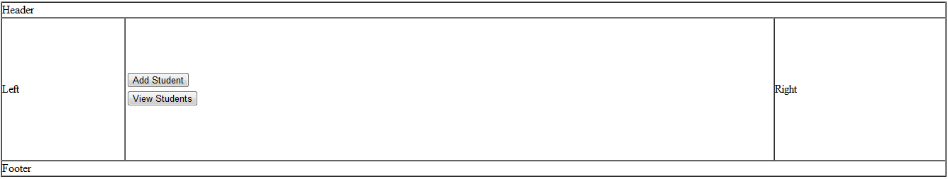

- Add screen:

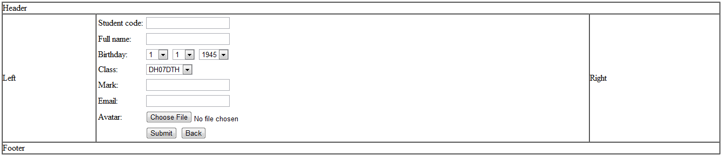

- List screen:

